December 24, 2023 Fourth Sunday of Advent

Today is a very busy liturgical day! In the morning we celebrate the Fourth Sunday of Advent, and later in the day we celebrate the Christmas Eve Vigil. There is no Fourth week of Advent because we will enter the Christmas season. On Sunday morning the fourth candle is lit on the Advent wreath representing Love. On this fourth Sunday of Advent, the liturgy shifts our attention from John the Baptist to Mary, the mother of Jesus. We are familiar with the story of the Annunciation, when God announced the birth of Jesus as we make our final preparations for our celebration of the Incarnation. The angel Gabriel visited Mary, a virgin betrothed to a man named Joseph. Mary greeted the angel’s news with awe and wonder and asked how it could be possible that she could give birth to a child. In his reply, the angel Gabriel announced the seemingly impossible reality: the child to be born would be conceived by the power of the Holy Spirit and would be God’s own Son. Mary’s response to the angel, which is called her fiat, is an example of complete faith and obedience to God.
Mary’s example of faith and obedience to God, traits which permitted her to receive the angel’s message that God’s Son would be born as a human person, as one of us.
At this time, we rejoice in the endless love that God has for us, which is made apparent in the birth of his Son. We reflect on the good news of God's love divine brought to us from the angel Gabriel.
Becoming Missionary Disciples- The challenges of faith is to recognize God’s plan for us and to remain open to God’s will and God’s actions in our world. Filled with God’s grace, Mary models for us the kind of faith that is needed to cooperate in God’s plan of salvation. Like Mary, we are given the awesome opportunity to cooperate in God’s saving plan. On this final Sunday of Advent, our Gospel invites us to consider how our preparations for Christmas have made us more aware of God’s grace working in our lives.
1st Reading: 2 Sm 7:1-5, 8b-12, 14a, 16 Responsorial Psalm:Ps 89:2-3, 4-5, 27, 29 Second Reading:Rom 16:25-27 Gospel:Lk 1:26-38

Note to all families,
First of all, from our oﬃce to your homes, we wish you a Very Blessed Christmas season. We thank you for your support as you use these publications with your families.
The Diocese of Syracuse is very happy to have launched a new website platform. The new website includes a page from our oﬃce to support faith in the family. There are many resources for you, but most of all we want to let you know that the BuildingFaith@Home pages can be found at:

syracusediocese.org/partnering- with-families

You may also sign up to receive the weekly editions directly to your email by registering at:

bit.ly/Register-Building-Faith

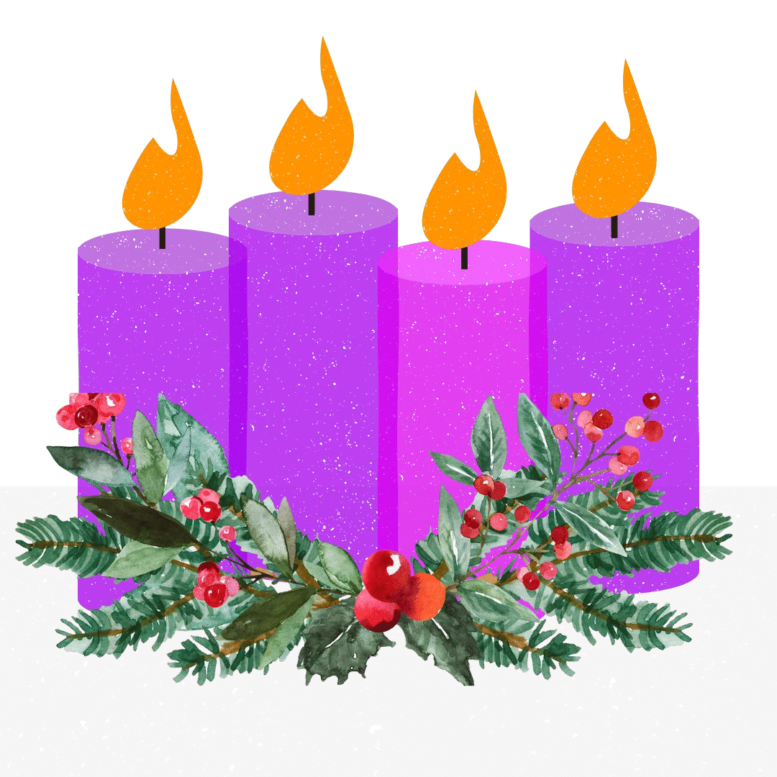
Family Table Talk
Are you looking for Christmas music? Here are some music videos for your enjoyment during the Christmas season.
youtube.com - Instrumental Christmas Music (3 hours of piano Christmas classics)
Youtube.com - Joyful Christmas Fireplace with Traditional Instrumental music (8 hours of music with fireplace)
Youtube.com Traditional Choir Peaceful Christmas Music and Ambience (1 hour of choir voices)
For the whole family…
How can Mary’s faith in God help you to say yes to God in your own life?
“In what ways can we show God’s love to others?”

Candle Name: the Angel's Candle
Lighting the
The Fourth Week of Advent Represents: Love Candle Color: Purple
Fourth
During the final week of Advent we rejoice in the love that God has for us, which is made apparent in th birth of his Son. We reflect on the good news of God's love brought to us from the angel Gabriel.
Candle

Links for More Ideas, Activities & Resources FYI
Diocese of Syracuse: Twelve Days of Christmas with the Saints (Family Faith Builder) DynamicCatholic.com - The Catholic Meaning of the 12 Days of Christmas (Family Faith Builder) Catholicicing.com - Epiphany House Blessing with Chalk (Family Faith Builder) LoyolaPress.com - New Year’s Prayer (Family Faith Builder)
Please note that our next issue will not be published until January 14, as we enter Ordinary Time once again.
This resource is meant to be used in a digital format with hyperlinks,
Digital Format can found at:

syracusediocese.org/partnering-with-families

Psalm 46:10
Prayer Time This Week!
December 24, 2023
The Magnificat
My soul proclaims the greatness of the Lord; My spirit rejoices in God my savior.
For he has looked upon his handmaid’s lowliness; behold, from now on will all ages call me blessed.
The Mighty One has done great things for me, and holy is his name. His mercy is from age to age to those
who fear him.
He has shown might with his arm, dispersed the arrogant of mind and heart.
He has thrown down the rulers from their thrones but lifted up the lowly.
The hungry he has filled with good things; the rich he has sent away empty.
He has helped Israel his servant, remembering his mercy, according to his promise to our fathers, to
Abraham and to his descendants forever. Amen.

Cut & Pray!
Scripture Verse of the Week From Sunday’s Mass December 24, 2023

"Behold, I am the handmaid of the Lord.
May it be done to me according to your word."
Lk 1:38

Fiat means “let it be done.”
Write your own prayer to be open to saying
“yes” to God’s call.

Visio Divina - Reflective prayer through Sacred Art Adoration of the Shepherds by Gerard von Honthorst in 1622, captures the beauty of the Light Divine in the Holy Child. The painting is intensely quiet. This scene of meditation invites the viewer to adoration. As Mary teaches the shepherds, she teaches us, inviting us to adore the child,too. .Visit this piece of Sacred Art and take time to notice all that is happening.
Sit with the picture. Spend some time in your own adoration.
- Where do you focus when you look at the painting?
- Are you drawn to a particular person in the painting?
- Who are you in the painting?
- This is a quiet painting but if they were to speak, what would Mary, Joseph, the shepherds or Jesus say to you?
Building Prayer Time @ Home
This will be a series of family activities to try as your families start or strengthen prayer time.
Lighting the Fourth Candle of Advent
The fourth candle of Advent represents Love, the ultimate love of God that He might send His only Son for us. Called the “Angel’s Candle,” the fourth candle of Advent is lit the Sunday before Christmas, and it is the color purple.
*light all four candles
*Scripture Reflection: "And the angel said to them, “Be not afraid; for behold, I bring you good news of a great joy which will come to all the people; for to you is born this day in the city of David a Savior, who is Christ the Lord." Luke 2:10-11
*pause for reflection
*Advent Wreath Prayer: Dear Jesus, may the light of your love always shine in our hearts. As Christmas draws closer, we marvel at your great love for us. Let your love transform every aspect of our lives and touch everyone we encounter. Our hearts are open to you, Jesus. Amen.

