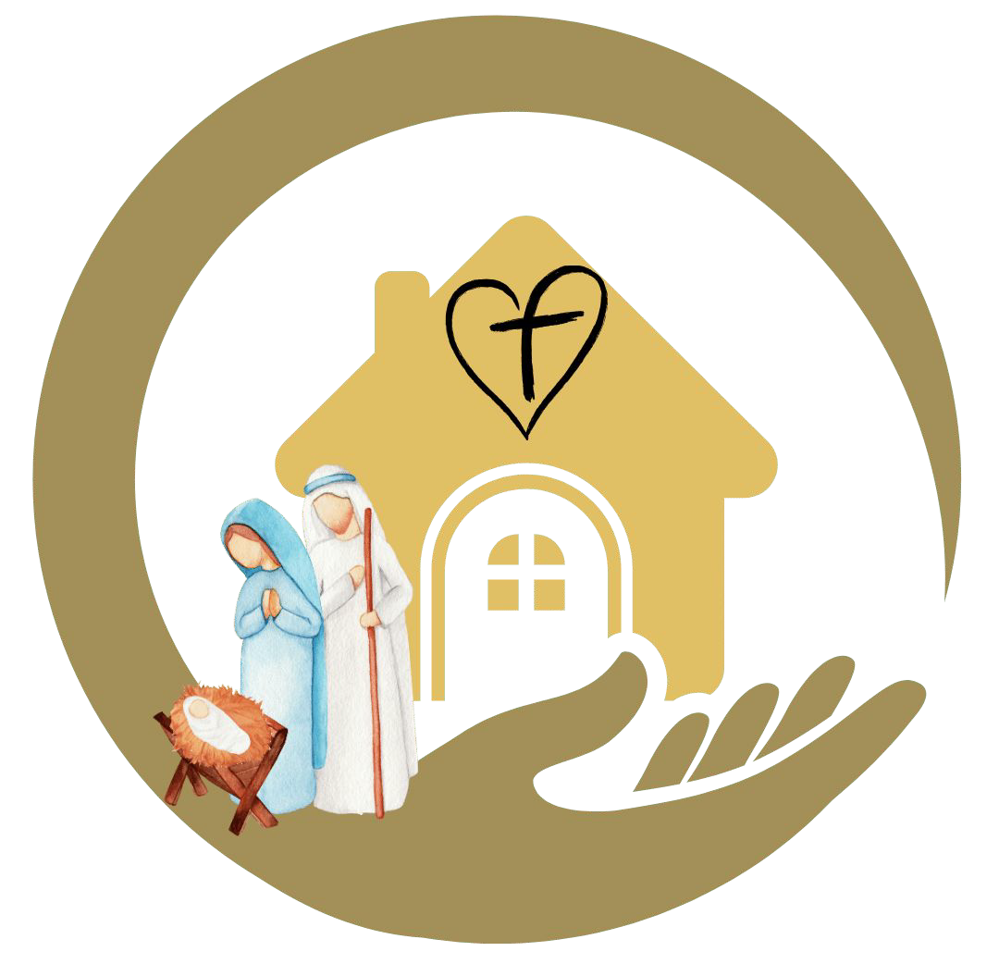
Special Edition

The Twelve Days of Christmas

Day 1 December 25 - Christmas Day
Merry Christmas! Thank you Jesus for coming to us as a little child and living among us to show us God’s love.
As a family, write a “Christmas card” to Jesus Thank him for coming to live among us as our Savior. Have all sign the card and place it near the creche.

Day 2 December 26 - St. Stephen’s Day.
He was the first Christian martyr. St. Stephen was one of the first 'social workers' in the Church, and it was his task to organize meals to feed the poor. Britain celebrates this day as “Boxing Day”
As a family, create a box to fill in gratitude of Christmas blessings. Add gifts of clothing or toys, etc and give to a family in need.

Day 3 December 27 - St. John the Apostle
On the third day is the feast of St. John, the Apostle, "whom Jesus loved." St. John is the patron saint of love, loyalty, friendships, and authors. He is often depicted in art as the author of the Gospel with an eagle, symbolizing "the height he rose to in his gospel.
As a family Don’t forget to say “I love you!” to each other.

Day 4 December 28 - The Feast of the Holy Innocents
Also known as the Feast of the Holy Innocents (and referred to as Childermas) refers to King Herod’s order found in Matthew’s account of the king’s reaction to the fulfillment of the Old Testament prophecy. (MT 2:16)
Pray for children around the world.

Day 5 December 29 - St. Thomas Becket
He was Archbishop of Canterbury in the 12th century and was murdered on 29th December 1170 for challenging the King’s authority over the Church. He is the patron saint of secular clergy. diocesan priest is sometimes called a secular priest.

Thank your parish priest and pray for him.

Day 6 - December 30
In the carol of the 12 days of Christmas, “on the sixth day of Christmas my true love gave to me, six geese a laying :” The number six is meant to represent the six days of Creation.
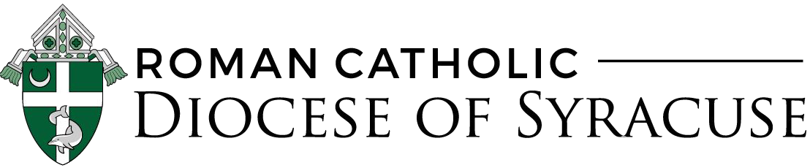
As a family, create a mural depicting the 6 days of Creation. Discuss how to be better stewards of God’s Creation.

Day 7 - December 31
In the carol of the 12 days of Christmas, “On the seventh day of Christmas my true love gave to me, seven swans a-swimming. The seven swans are meant to remind us of the seven gifts of the Holy Spirit . The gifts are: courage, wisdom, knowledge, understanding, reverence, awe & wonder, counsel.
As a family, identify these gifts in each other.

Day 8 - January 1- Solemnity of the Blessed Virgin Mary, Mother of God
This is also the “World Day of Peace”.
Say decade of the rosary with a focus on world peace and makes sure you wear blue in remembrance of Mary.

Day 9 - January 2- St. Basil the Great
One of St. Basil’s famous quotes is, “A good deed is never lost; he who sows courtesy reaps friendship, and he who plants kindness gathers love.”
― St. Basil
Each member of the family should do a good deed for another member of the family.

Day 10 - January 3 - Feast of the Holy Name of Jesus (Optional Memorial Day)
The Church reveals to us the wonders of the Incarnate Word by singing the glories of His name. The name of Jesus means Savior; it had been shown in a dream to Joseph together with its meaning and to Our Lady at the annunciation by the Archangel Gabriel.
Have the family members tell the stories of their names. Who are you named after? What does your name mean? Is it a saints name if yes who and discover their life story.

Day 11 - January 4 - St. Elizabeth Ann Seton
January 4, 2021 marks the 200th Anniversary Feast Day. She was the first citizen born in the United States to be given the title of “Saint.” She is the patron saint of Catholic schools.
As a family, commemorate and celebrate those family members who taught you through word and witness about the Catholic faith.

Day 12 - January 5 - Epiphany of the Lord
Because the actual Epiphany falls on a Tuesday, the Church will celebrate on the Sunday liturgy of January 3. On the Epiphany, the Magi recognizing Jesus as king, prophet and priest.
According to legend, the three magi were Caspar, Melchior and
Balthazar
Blessing your home : 20 + C + M + B + 21
For more information about this ritual visit, Busted Halo, Bless your door this Epiphany

